HOME PAGE

Our website aims to promote comprehension, empathy, and resilience by exploring the various family and community situations that influence children's early experiences. We offer a thorough resource for schools, families, and community professionals through five targeted sections: Economic, Social, Cultural and Diversity, Health and Wellbeing, and Crisis and Emergency environments.

We discuss how early childhood education may effectively respond to various circumstances and draw attention to their effects on children's learning, relationships, development, and well-being.

You will discover policy summaries, evidence-based tactics, and collaborations with important groups that assist educators and families. Family & Community Connections provides educators with the resources they need to create trauma-informed and culturally sensitive learning environments, reinforce community bonds, and ensure all children, regardless of background, achieve success.

Our vision- Gives educators and parents more power by offering resources, strategies, and insights into a range of family situations   to create culturally sensitive, trauma-informed early childhood settings where every child thrives, encourage empathy, resilience, and inclusion.

1. **Economic Contexts**

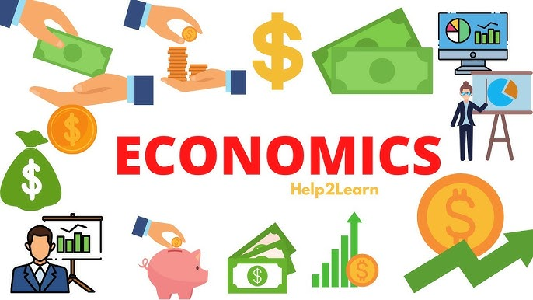

Understanding the economic context (Economic)

Many Australian families continue to be impacted by economic factors such poverty, homelessness, and housing insecurity, especially those headed by a single parent, members of Indigenous communities, and those who depend on social assistance (Grace et al., 2022). Children's access to excellent early childhood education is affected by the challenges these families usually face to finding steady jobs, affordable housing, and necessary resources (ACOSS, 2022). By influencing children's environment at home and in early learning settings, these external socioeconomic factors have an impact on their development, according to Bronfenbrenner's ecological systems theory (Grace et al., 2022).

Poverty can result in emotional stress, a delay in growth, and a lack of preparation for school. Early childhood educators therefore have to embrace trauma-informed, inclusive practices and promote equity. Due to the variety and changing character of Australia's economic suffering, which is made worse by a lack of available housing and growing living expenses, culturally sensitive and flexible remedies are required. To guarantee that every child, regardless of circumstance, has an equal chance to succeed in early education, research and policy reform must continue.

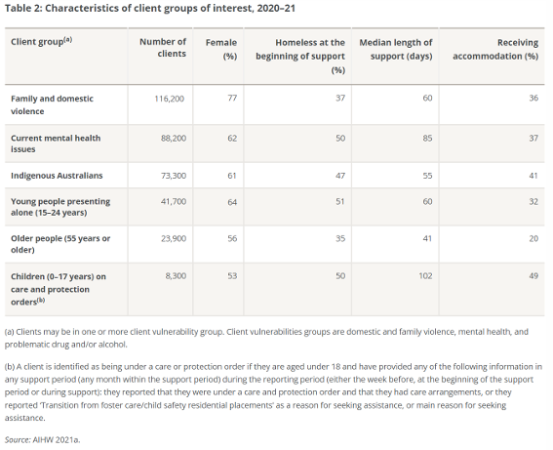

**Impact on Children and Families** (Economic)

Development, Learning, and Wellbeing: Lack of funds prevents people from having access to nutritious meals, secure housing, and high-quality education, which can result in delayed growth, poorer language proficiency, and poor physical and mental health, including more stress and trauma.

Relationships: Children's social relationships within families and communities are impacted by economic hardship because it increases parental stress, which in turn reduces responsive caring and reduces attachment.

Engagement: Children's regular attendance and participation in early education are restricted by barriers like cost, transport, and employment obligations. Their sense of engagement and belonging is further diminished by social exclusion and stigma.

To meet the differing needs of families, services must use adaptable, inclusive strategies like outreach initiatives and culturally sensitive procedures.  In order to establish trust and work together on children's learning and well-being, strong family-teacher relationships are essential.  To improve results for vulnerable families, ECE settings should support policies that address structural barriers, including income support and affordable housing.

**Social Policy and Australian Responses** (Economic)

key national and state policies, strategies, or initiatives related to the issue

* National Housing and Homelessness Agreement (NHHA)
* National Early Childhood Education and Care (ECEC) Reforms.
* National Disability Insurance Scheme (NDIS)
* State-level Affordable Housing Strategies.
* Income Support Programmes: Federal benefits including Youth Allowance, Parenting Payment, and Jobseeker help families that are struggling financially.

Statistics to highlight the scope and urgency of the economic context

In Australia, 16.6% of children live in poverty, and the percentage is substantially higher for Indigenous and single-parent households (ACOSS, 2022).  
  
On any given night, about 122,000 people are homeless, with the fastest-growing demographic being children under the age of 12 (AIHW, 2022).  
  
The rising cost of living- Families are under additional strain, and the welfare and development of children are at risk, as the cost of living—which includes housing, food, and childcare—continues to rise faster than wages (ABS, 2023).



How policy responses influence early childhood practices.

Early childhood practices are directly affected by policy responses to economic issues like homelessness, increasing living expenses, and COVID-19. Children's access to education is improved by support programmes including financial aid and Specialist Homelessness programmes. However, participation is still limited by persistent housing and employment restrictions. As a result, educators promote inclusive, trauma-informed practices, and services interact closely with families to promote health and well-being regular attendance, curriculum delivery, staff development, and community involvement tactics.

**Strategies for Practice** (Economic)

By emphasising their potential and fostering resilience, use strengths-based strategies to empower parents and children (Emerging Minds, 2023).

To reduce financial stress, put families in touch with neighborhood services including food banks, housing, and financial assistance (Emerging Minds, 2023).

To improve children's emotional intelligence and resilience, implement Social and Emotional Learning (SEL) programmes like MindUP and FRIENDS for Life (Be You,2023).

Adopt family-centered strategies that customise support to meet the requirements of each family by involving parents and carers in decision-making (Raising Children Network, 2023).

In the face of financial difficulties, foster secure relationships and good development by promoting loving, responsive, and flexible caregiving (Raising Children Network, 2023).

By building trustworthy connections with families, putting them in touch with neighbourhood resources, and establishing welcoming, caring spaces, early childhood educators may put these tactics into practice. They can put SEL programmes into place to help children develop how to cope, encourage strengths-based behaviour, and encourage positive parenting. These strategies assist families in lessening the effects of financial hardship, housing stress, and poverty.

**Community and Professional Partnerships** (Economic)

* Department of Social Services (DSS)-supports families with its Financial Wellbeing and Capability services.
* Australian Institute of Family Studies (AIFS)- offers services that assist vulnerable and food-insecure family’s evidence-based recommendations.
* Australian Institute of Health and Welfare (AIHW)-Tailored assistance is influenced by statistics on welfare requirements.
* Red Cross- Offers fee alleviation as part of its crisis recovery aid.
* The Salvation Army- Families experiencing poverty and adversity can get food help, housing support, and cash.

The following organisations offer vulnerable family’s evidence-based services, immediate help, food and housing assistance, and financial coaching. Through recommendation pathways, co-delivering family support programmes, providing educator training, and communicating data to determine needs, they can work in tandem with early childhood services. This collaboration guarantees comprehensive, prompt assistance for families facing financial difficulties, housing stress, or poverty.

**Resources for Educators and Children (Economic)**

Websites 

* Raising Children Network
* The Smith Family
* Economic impacts - Department of Planning and Environment NSW Government
* Local Government and Economic Development Victorian Auditor-General's Office

Books 

* I am money by Julia Cook
* Bunny Money by Rosemary Wells
* Those Shoes by Maribeth Boelts
* Still a Family by Brenda Reeves Sturgis

children programmes 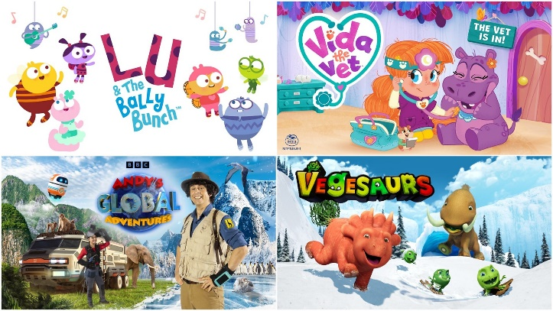

* Sesame Street in Communities– Housing
* Daniel Learns About Neighbourhood Jobs
* Markets but In Reversed BLUEY IN REVERSED
* Economics for kids

Children facing or learning about economic issues can benefit greatly from the awareness, empathy, and resilience that websites, books, and children's programmes can impart. Websites having economic context offer educators and families easily accessible support resources, promoting discussions about community support, budgeting, and needs. Children learn about homelessness and poverty through books, which develops their emotional intelligence and empathy. Through engaging storytelling and characters, children's programmes present real-life economic problems, fostering resilience by normalising difficulties and giving children the tools, they need to share, cope, and assist others

1. **Social Contexts**

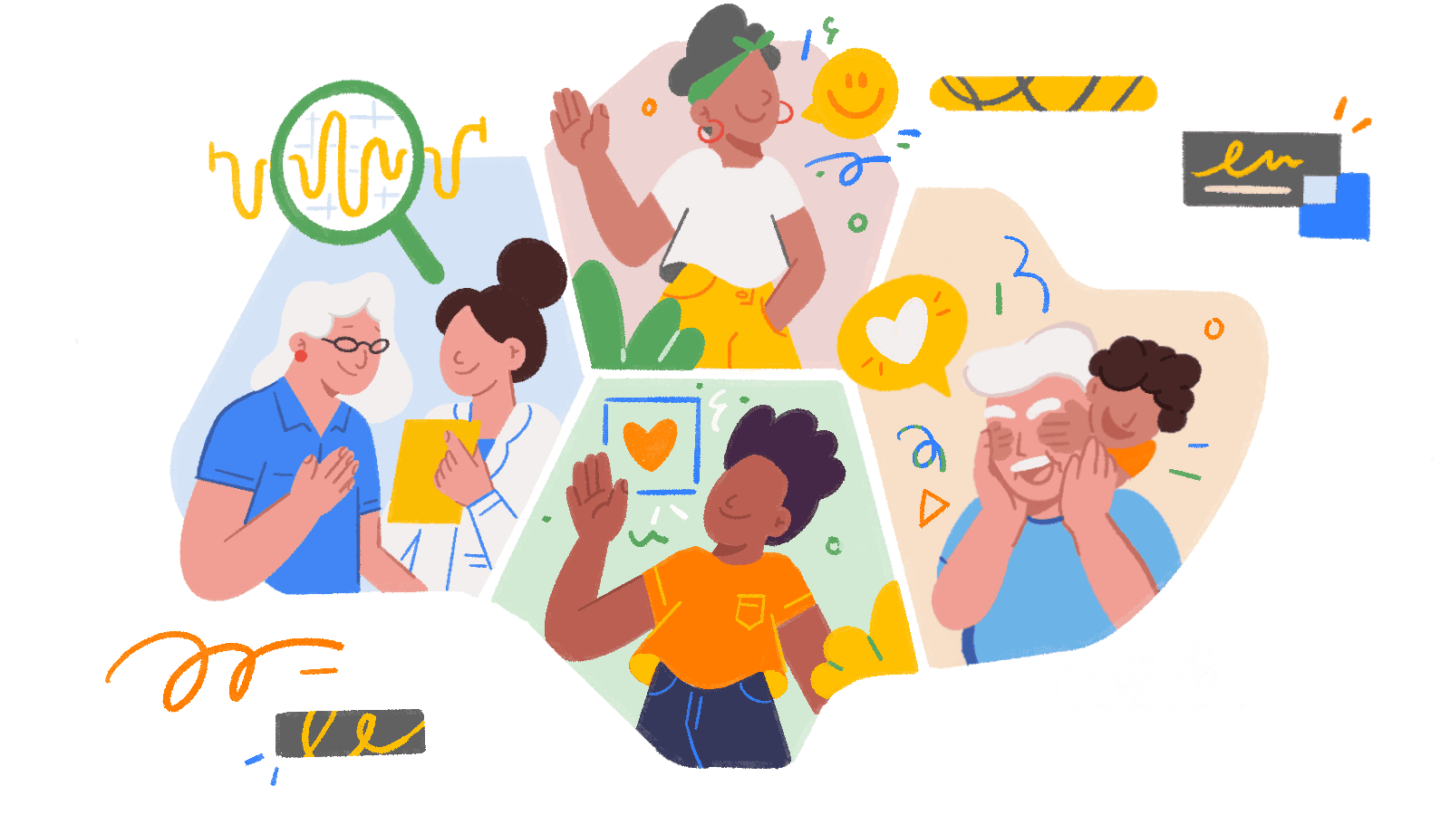

**Understanding the Context (Social)**

Complex socioeconomic problems like trauma, instability, and broken attachments are common among families receiving out-of-home care because of child protection concerns (Hodge & McMahon, 2022). Socially isolated families such as those in rural areas, single-parent households, or where parents struggle with substance abuse or mental illness—face additional difficulties (Grace et al., 2022). Due to the possibility of placement in foster, kinship, or residential care for children from such backgrounds, early childhood education is essential for ensuring continuity, mental stability, and trauma-informed support. Good ECEC fosters community connections and stable relationships, which act as a buffer against adversity. According to Bronfenbrenner's ecological systems theory, a child's family and care surroundings are among the interrelated systems that influence their development. Although general access and other programmes seek to address these discrepancies, family engagement is not obviously a result of enrolment, particularly in cases where services are not seen as culturally safe. Access to ECEC does not, however, guarantee participation, particularly in cases when cultural safety is lacking in the programmes. The necessity of responsive care is further supported by attachment theory. In order to address growing structural imbalances and promote children's holistic development and well-being, inclusive and flexible ECEC practices are required as child protection legislation change, particularly for Aboriginal children.

**Impact on Children and Families (Social)**

Social circumstances that affect children's growth, learning, wellbeing, relationships, and involvement include social isolation, divorce, and out-of-home care. These elements may result in diminished chances for constructive social interactions, emotional distress, attachment disruption, and restricted access to early learning (Grace et al., 2022). Developmental risks and delayed learning outcomes are more common in children from out of care or socially isolated homes. By offering secure, encouraging, and stimulating environments that foster resilience, healthy relationships, and holistic development, quality early childhood education and care, or ECEC, is essential in reducing these negative effects (Grace et al., 2022).

Separation, and a lack of care however, frequently make it difficult for the neediest children to get high-quality ECEC. This emphasises the necessity of trauma-informed care, inclusive practices, community involvement, and funding for qualified teachers in early childhood services. Families must see services as supportive and culturally secure environments to guarantee long-term developmental advantages and active engagement (Grace et al., 2022).

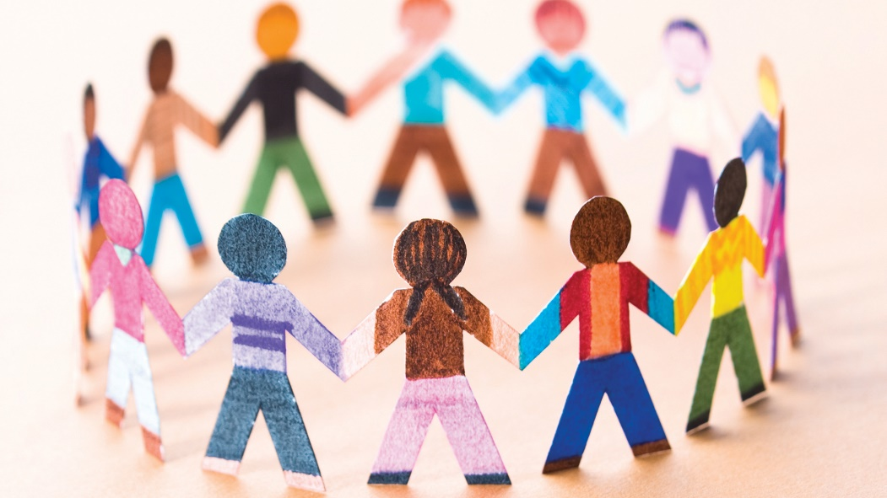

**Social Policy and Australian Responses (Social)**

Commonwealth, state/territory, and Aboriginal representatives work together on child safety and welfare under the National Framework for Protecting Australia's Children 2021–2031, which includes the National Standards for Out-of-Home Care (AIHW, 2022).

In order to prevent or reverse care placements, extensive family support services are provided, and Child Protection Australia reports track rates of children in care, admissions, and support services (AIHW,2022).

In Australia, 45,300 children were in out-of-home care as of June 30, 2023, which is equivalent to a rate of 7.9 per 1,000 children (ABS,2023).

With a rate of 57 per 1,000, 19,700 of them were Aboriginal and Torres Strait Islander children, whereas the rate for non-Indigenous children was 4.7 per 1,000 (ABS,2023).

The concentration of Indigenous children in long-term placements, particularly in distant and regional locations, where rates are higher than 12–14 per 1,000, as opposed to 6.0 per 1,000 in metropolitan cities (AIHW,2022).

The National Framework for Protecting Australia's Children, which requires trauma-informed, culturally sensitive ECEC practices, and national policies (such as NDIS inclusion and Closing the Gap) are informed by these figures. Reducing care admission, promoting reunion, and influencing early education programmes to place a higher priority on equity and inclusion are the goals of targeted investment in family support services.

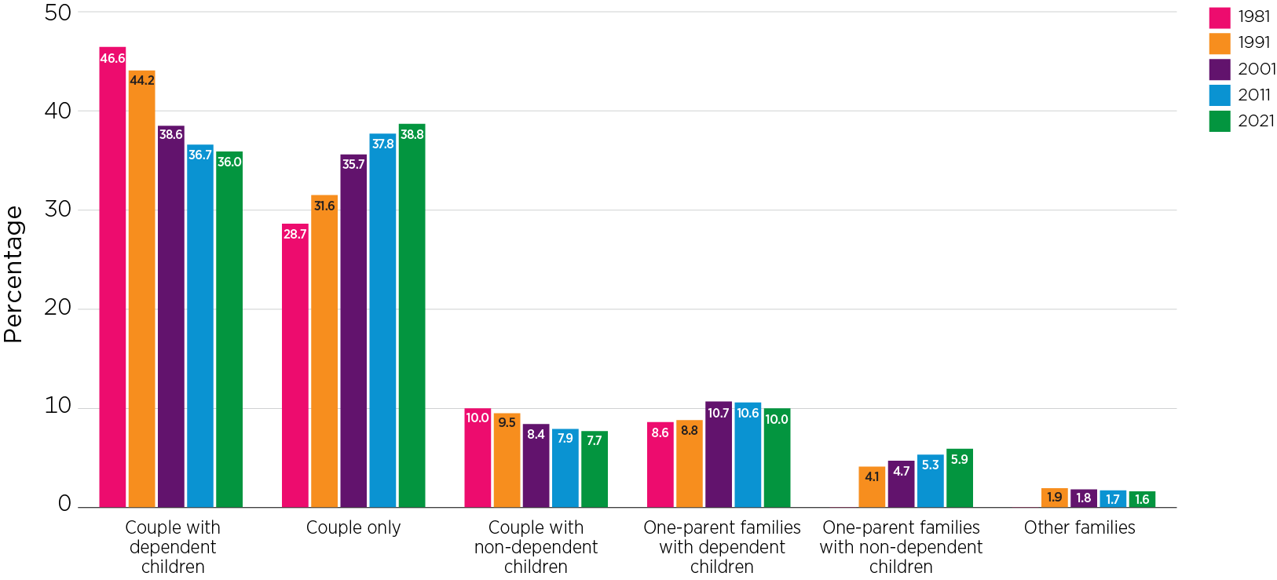

**Strategies for Practice (Social)**

* Create a safe and predictable environment (Be You, 2020)
* Strengthen emotional literacy and regulation (Emerging Minds,2017)
* Build strong, positive relationships (Raising Children, 2006)
* Encourage family engagement and cultural safety (Be You, 2020)
* Connect families with support services (Emerging Minds, 2017)

Early childhood teachers can integrate trauma-informed care into daily activities, establishing clear structures and delivering emotional support. By offering tools and conducting meetings in culturally appropriate ways, educators can cultivate ties with families. Teachers can involve members of the local community and incorporate traditional activities for Indigenous children. Referring families to social services, providing advice, and keeping in touch to guarantee continuity of care are all ways to build collaborative support.

**Community and Professional Partnerships (Social)**

* Child Protection Services
* NDIS (National Disability Insurance Scheme)
* Emerging Minds
* Family Support Services (e.g. Anglicare, Barnardos)
* Australian Council of Social Services (ACOSS)

By providing specific knowledge and resources to support vulnerable children and families, these institutions play a critical role in supporting early childhood programmes. By working together, they can assist in creating tailored care and education plans that consider each child's particular requirements and situation, particularly those who have experienced trauma or social hardship. To improve their capacity to successfully help children, professionals from these programmes can train educators in trauma-informed and culturally responsive methods. Additionally, by bridging cultural divides, groups like ACCOs help make sure families feel valued and included. These collaborations provide stability, consistency, and a holistic approach to learning and well-being (Grace et al., 2022).

**Resources for Educators and Children (Social)**

**Websites** 

* **Beyou**
* **Kids matter**
* **Raising Children Network**
* Emerging Minds

**Books** 

* **Say Hello by Jake Foreman**
* **Kind by Alison Green**
* **Hands are not for Hitting by Martine Aggasi**
* **My way to making friends by Elizabeth Cole**

**Children Programmes** 

* **Daniel Tiger’s Neighborhood –Friends Help Each Other**
* **Sesame Street**
* **Bluey**
* **coco melon sharing song**

Websites like Be You, KidsMatter, Raising Children Network, and Emerging Minds provide educators and families with useful tools to enhance children's social and emotional development while fostering empathy and resilience. Books with a social context teach young children the value of friendship, kindness, and polite behaviour, emotional control, and social confidence. Children's programmes make social skills simple to comprehend and use in everyday situations by modelling cooperation, empathy, and solving problems.

1. **Cultural and Diversity Contexts**

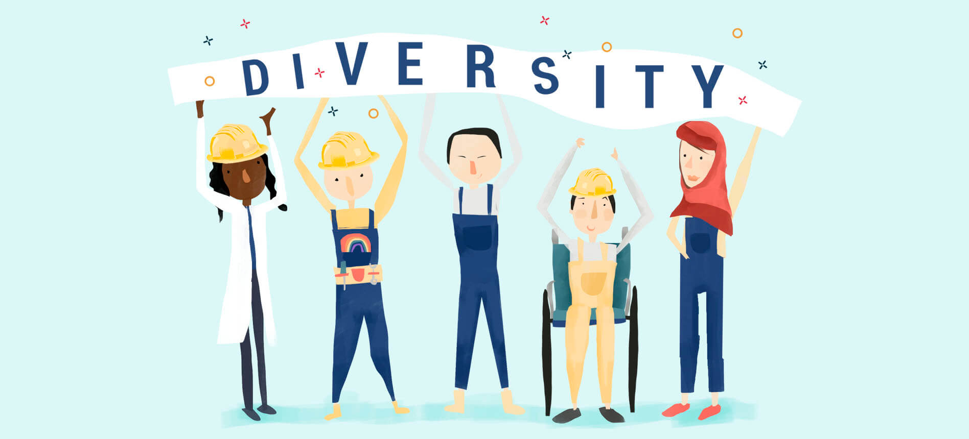

**Understanding the Context (Cultural and Diversity)**

The chosen family or community is described as follows: Refugee families frequently come to Australia after facing trauma, forced relocation, or a significant loss. Language challenges, unfamiliar social structures, disrupted family units, and mental health issues are just a few of the difficulties they encounter. These families might be socioeconomically disadvantaged and need assistance reestablishing their life and feeling accepted in a foreign nation (Sanagavarapu, 2022).

Relevance to early childhood education: Refugee children start to establish new identities, relationships, and cultural ties in early childhood settings. Educators are essential in promoting security, diversity, and cultural understanding. Educators can promote children's wellness, sense of belonging, and engagement in the learning process by identifying and respecting their memories and family stories (Sanagavarapu, 2022).

Sociological theories and research: Bronfenbrenner's ecological systems theory, Kids in Communities Study(KiCS) and Culturally and linguistically diverse (CALD) women’s experiences of technology‑facilitated violence: An intersectional approach emphasises how relationships between various systems impact the development of refugee children. In attempt to promote resilience, current research highlights trauma-informed, strengths-based strategies that respect children's rights to identity, culture, and emotional safety in early learning settings (Sanagavarapu, 2022).

**Impact on Children and Families (Cultural and Diversity)**

**Children's identity, sense of belonging, and education are greatly impacted by cultural and diverse situations, such as those faced by First Nations, immigrant, or refugee families. Children's engagement and emotional wellbeing may be impacted by experiences of racism, marginalisation, or separation from their cultural background. Support that is culturally appropriate can promote self-worth, resilience, and improved connections with teachers and peers** (Grace et al., 2022)**.**

**It is essential that early childhood services embrace cultural diversity and embrace inclusive, anti-bias measures. In order to ensure that services include a variety of worldviews and traditions, policies and programmes should be co-designed with communities. Children's educational outcomes are enhanced and trust is enhanced when bilingualism, cultural customs, and family participation are encouraged** (Grace et al., 2022)**.**

**Critical theory highlights how systemic inequality and power differences influence children's experiences (Woodrow et al.2022). Participatory, strengths-based approaches that upend deficiency perspectives and advance equity are recommended. Meaningful participation, inclusive settings, and better access to high-quality early childhood education for all children are all facilitated by culturally competent methods** (Grace et al., 2022)**.**

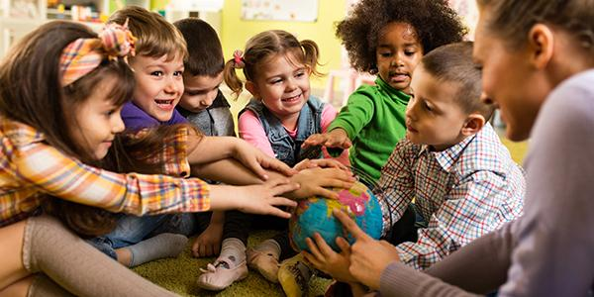

**Social Policy and Australian Responses (Cultural and Diversity)**

**Improve outcomes for First Nations and refugee or immigrant families are informed by policies like the National Settlement Framework and the National Agreement on Closing the Gap (2020). Action plans for diversity and reconciliation at the state level seek to promote participation, equity, and cultural safety (Grace et al., 2022). These policies highlight self-determination, culturally safe service delivery, and coordinated community assistance.**

**Compared to their non-Indigenous peers, First Nations children are twice as likely to face developmental vulnerability (Grace et al., 2022). Language challenges, trauma, and interrupted education are some of the difficulties faced by refugee children. For culturally and linguistically diverse (CALD) families, systemic inequalities increase disadvantage by limiting access to social, educational, and health resources (Grace et al., 2022).**

**These policies promote anti-bias education, community consultation, and culturally relevant paedagogy. Effort to establish inclusive, empowering environments for all children, early development programmes are motivated to embrace cultural competency, form partnerships with families, and confront discriminatory systems.**

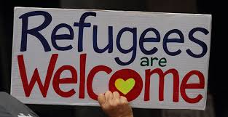

**Strategies for Practice (Cultural and Diversity)**

* **Culturally responsive pedagogy: Children's native languages, immigration, and identities are respected and incorporated into culturally responsive education.**
* **Family engagement: Building respectful connections with culturally and linguistically diverse (CALD) families in order to co-create learning.**
* **Anti-bias curriculum: Actively address bias, stereotypes, and discrimination while advancing inclusion and equity.**
* **Culturally inclusive assessment instruments: Make use of observational instruments that honor cultural differences in children's growth, such as storytelling or community engagement.**
* **Community partnerships: Working together with interpreters and cultural institutions to link families with support systems.**

**Early childhood educators can implement these tactics by incorporating stories, songs, and celebrations from several cultures into the curriculum. They can also use visual aids and translated materials to interact with families. By creating regular routines and demonstrating empathy, educators foster safe spaces for children to express their identities and promote their emotional health. Educators may create inclusive, encouraged learning environments by involving families in decision-making and challenging biases through reflective practice. For children and families from First Nations backgrounds, working with multicultural support programmes improves resilience and connection.**

**Community and Professional Partnerships (Cultural and Diversity)**

* **ACECQA- Australian Children’s Education and Care Quality Authority**
* **Be You**
* **Australian Institute of Family Studies (AIFS)**
* **Australian Education Research Organisation (AERO)**
* **Foundation House**

These organisations are important in educating teachers to work with First Nations and culturally and linguistically diverse (CALD) families in early childhood settings. In aim to promote a strong sense of engagement and belonging, they support services in creating inclusive curricular frameworks that represent children's cultural identities. Educators develop expertise in cultural ability, anti-bias methods, and trauma-informed care through co-delivered courses and training. Additionally, organisations offer materials in other languages to facilitate communication with families who might not speak English. In order to assist educators in meeting challenging demands, they provide referral paths to specialised support services. Crucially, they support culturally safe settings that respect a range of beliefs, customs, and worldviews, enabling families to take an active role in their children's education.

**Resources for Educators and Children (Cultural and Diversity)**

**Websites** 

* **SNAICC – Secretariat of National Aboriginal and Islander Child Care**
* **Early Childhood Australia – Code of Ethics and Cultural Competency Resources**
* **Australian Human Rights Commission – Education for a Fairer World**
* **Raising Children Network – Cultural Diversity and Parenting**

**Books** 

* **I’m Australian too by Mem Fox**
* **The little refugee by Anh Do**
* **All are welcome by Alexandra Penfold**
* **All people are Beautiful by Vincent Kelly**

**Children’s Programmes** 

* **Sesame Street – “Meet Ji-Young” and “We Belong” Series**
* **Bluey – “Baby Race” and “Turtleboy” Episodes**
* **Little J & Big Cuz**
* **HiHo Kids-Kids share their cultural traditions**

Websites offer culturally sensitive materials to foster identification, belonging, and inclusion in a variety of contexts for educators and families. Children can develop empathy and pride in their varied roots by reading books about many cultures, migration experiences, and family histories. As children learn to value and celebrate differences, children's programmes foster understanding, respect, and resilience by introducing cultural traditions, language, and identity via captivating stories.

1. **Health and Wellbeing Contexts**

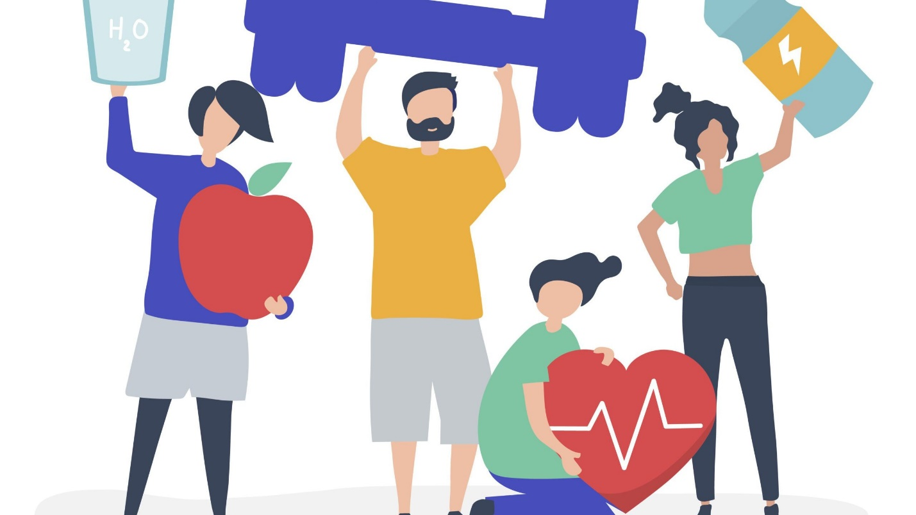

**Understanding the Context (Health and Wellbeing)**

Complex family problems that include parental mental illness, substance abuse, domestic violence, trauma, grieving, and abuse are all included in health and wellbeing contexts. Adverse childhood environments are created by the regular overlap of these experiences. A parent with a mental illness educates up to one in four Australian children, leaving them at higher risk for emotional, cognitive, and behavioural problems **(Grace et al., 2022)**.

These problems have a direct impact on how children conduct themselves, grow, and interact with others in early learning environments. In order to recognise symptoms of distress, create safe bonds, and promote resilience, educators are essential. For children's well-being and long-term results, inclusive and trauma-informed methods are essential **(Grace et al., 2022).**

Through disturbed microsystems, family adversity affects development, according to by Bronfenbrenner's ecological systems theory. John Bowlby's attachment theory lays a strong emphasis on how early parent-child connections impact a child's social, emotional, and cognitive growth. According to recent research, parent-child interactions are impacted by parental mental illness and trauma, which results in inconsistent parenting and decreased engagement **(Grace et al., 2022)**.

The effects of trauma and mental illness different among Indigenous, cultural, and socioeconomic groups. These issues are made greater by structural injustices, stigma, and restricted access to services, necessitating equitable and culturally appropriate teaching methods **(Grace et al., 2022)**.

**Impact on Children and Families (Health and Wellbeing)**

Childhood development is severely hampered by health and wellness issues such parental substance abuse, trauma, and mental illness. Social interactions, emotional control, language acquisition, and cognitive functioning can all be impacted by these situations. Caregiving that is inconsistent or emotionally unavailable can cause children to feel insecure, have low self-esteem, and have trouble building trustworthy connections (Grace & Baird, 2022). Long-term effects on learning, behaviour, and mental health can result from chronic stress's impact on brain development.

Children who have experienced challenges, early childhood services must include relational, inclusive, and trauma-informed approaches. Building solid, receptive relationships while offering secure, nurturing environment are important tasks for educators. In order to meet complicated family needs and lessen the effects of social injustices, services must also work together with related specialists. To guarantee each child's right to safety, belonging, and holistic development, culturally sensitive methods and solid family relationships are crucial (Grace & Baird, 2022).

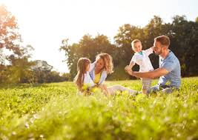

**Social Policy and Australian Responses (Health and Wellbeing)**

The National Mental Health and Suicide Prevention Plan, the National Preventive Health Strategy 2021–2030, and the National Mental Health Workforce Strategy 2022–2032 are important national and state initiatives that address health and wellness. Victoria's Victorian Public Health and Wellbeing Plan 2023–27 and the Vision for Raising Standards of Learning and Development (2013) support holistic approaches to health by encouraging prevention, early intervention, safe environment, and healthy relationships.

21.5% of people had a 12-month mental disorder, with Anxiety being the most common group (17.2% of people aged 16–85 years) (ABS,2023). 38.8% of people aged 16–24 years had a 12-month mental disorder (ABS,2023). Mental health-related presentations to public emergency departments have increased by 22% since 2014-15 (AIHW,2023). Nearly 50% of the people in Australia suffer from at least one chronic illness, such as diabetes, heart disease, asthma, or arthritis (AIHW, 2023).

By encouraging early intervention, mental health awareness, and preventative treatment, policy responses have an impact on early childhood practices. They provide guidance to educators on how to work with health services, create safe and encouraging environments, and include wellbeing into the curriculum. These methods promote children's long-term health and holistic development while helping in early identification of problems.

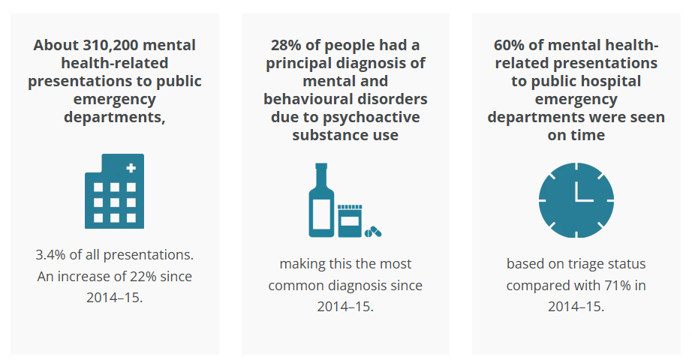

**Strategies for Practice (Health and Wellbeing)**

* building strong educator-child relationships.
* Fostering secure attachments.
* Promoting emotional regulation skills.
* Engaging families through respectful communication.
* Providing consistent routines (Hodge & McMahon, 2022).

By creating caring environments where children feel secure and appreciated, early childhood educators may put these strategies into practice. Through regular updates and cooperative planning, they can engage families in learning, teach coping techniques through role-playing and storybooks, and serve as role models for healthy emotional expression. Emotional wellbeing is supported and anxiety is lessened by upholding regular routines and providing composed, receptive relationships. In order to provide children and families with focused care, educators also work together with allied health experts when necessary. These methods foster beneficial developmental outcomes and increase protective factors.

**Community and Professional Partnerships (Health and Wellbeing)**

* Primary Welfare Officers
* National Mental Health Commission
* Emerging Minds
* ACECQA
* Child and Family Hubs

occurs as a result of case conferences, warm referrals, shared care plans, and regular communication. These organisations support educators in promoting holistic development, recognising needs early, and obtaining professional support. In order to establish inclusive, trauma-informed environments that put children's safety, resilience, and mental health first, educators also get professional development. These collaborations improve community connections and family involvement.

**Resources for Educators and Children (Health and Wellbeing)**

Websites 

* Raising Children Network
* Emerging Minds
* Be You
* Healthy Kind- NSW Health

Books 

* I Don’t Want to Wash My Hands!” by Tony Ross
* Germs Are Not for Sharing” by Elizabeth Verdick
* How Do Dinosaurs Get Well Soon?” by Jane Yolen & Mark
* My Magical Foods by Becky Cummings

Children’s Programmes 

* Sesame Street – “Healthy Habits for Life” Series
* Daniel Tiger’s Neighborhood – “When You're Sick” & “Taking Care of You” Episodes
* Bluey – “Bike” and “Calypso” Episodes
* Mindstars Kids- Healthy bodies, healthy minds

1. References

Grace, R., et al. (2022). Children, Families and Communities (6th ed.). Oxford University Press Australia & New Zealand. ProQuest Ebook Central, http://ebookcentral.proquest.com/lib/ikoninstituteau/detail.action?docID=7074339.

AIHW. (2022). Homelessness and homelessness services. <https://www.aihw.gov.au/reports/australias-welfare/homelessness-and-homelessness-services>

ACOSS & UNSW. (2022). Poverty in Australia 2022. <https://povertyandinequality.acoss.org.au/poverty/>

Be You. (2020). Programs directory*: MindUP and FRIENDS for Life.* https://beyou.edu.au/resources/implementation-tools/programs-directory

Emerging Minds. (2017). *Child and family strengths and vulnerabilities*. <https://emergingminds.com.au/resources/in-focus-child-and-family-strengths-and-vulnerabilities/>

Raising Children Network. (2006). *A family-centred approach.* https://raisingchildren.net.au/for-professionals/working-with-parents/about-working-with-parents/professionals-a-family-centred-approach

Raising Children Network. (2006). *Families experiencing challenges.* <https://raisingchildren.net.au/for-professionals/working-with-parents/about-working-with-parents/families-experiencing-challenges>

**Zamora, C. L., Boddy, J., O’Leary, P., & Liang, J. (2022).** Culturally and linguistically diverse (CALD) women’s experiences of technology‑facilitated violence: An intersectional approach. In A. Powell, A. Flynn, & L. Sugiura (Eds.), The Palgrave Handbook of Gendered Violence and Technology (pp. 115 – 134). Palgrave Macmillan. <https://research-repository.griffith.edu.au/items/ad1b010c-d409-4f36-b044-23656342ab5d>

Goldfeld, S., Villanueva, K., Tanton, R., Katz, I., Brinkman, S., Giles‑Corti, B., & Woolcock, G. (2017). *Kids in Communities Study (KiCS) study protocol: A cross‑sectional mixed‑methods approach to measuring community‑level factors influencing early child development in Australia. BMJ Open,* 7(3), e014047. <https://www.mcri.edu.au/research/projects/kics>

Australian Children's Education & Care Quality Authority (ACECQA). (2020). Supporting cultural diversity. https://www.acecqa.gov.au

Australian Institute of Family Studies (AIFS). (n.d.). Child care in cultural context: Issues for new research. https://aifs.gov.au

Australian Education Research Organisation (AERO). (2022, September 7). *Engaging with families from culturally and linguistically diverse backgrounds*. <https://www.edresearch.edu.au>

Department of Education and Training Victoria. (n.d.). *Primary welfare officers.* https://www.education.vic.gov.au/school/teachers/health/Pages/expired/welfarepartnerships.aspx

National Mental Health Commission. (2023). *Focus area 1: Family and community – Children’s mental health and wellbeing strategy.* https://www.mentalhealthcommission.gov.au/projects/childrens-strategy/childrens-mental-health-wellbeing-strategy/childrens-mental-health-wellbeing-strategy-report/focus-areas/focus-area-1-family-and-community

Centre for Community Child Health. (n.d.). *Child and family hubs framework: Background, purposes, underpinning and principles*. <https://www.ccch.org.au/media/kcunfraf/final-child-and-family-hubs-framework-document-1-background-purposes-underpinning-and-principles.pdf>

Department of Planning and Environment NSW Government. (2024, December 3). *Economic impacts – Guidelines for state significant projects*. https://www.planningportal.nsw.gov.au/key-guidance

Victorian Auditor-General's Office. (2018, March 8). *Local government and economic development.* https://www.audit.vic.gov.au/report/local-government-and-economic-development

Raising Children Network. (2024, June 28). *Parenting payments.* https://raisingchildren.net.au/managing-money/government-financial-aid/parenting-payments

The Smith Family. (n.d.). *Learning for Life program.* https://www.thesmithfamily.com.au/programs/learning-for-life

KidTimeStoryTime. (2024). I am money | *Money read aloud for kids a Julia Cook book!* [Video]. YouTube. https://www.youtube.com/

Miss Jill Toadstools and Fairy Dust. (2022). *Bunny Money Read aloud books for children |* Storytime| Responsibility [Video]. YouTube. https://www.youtube.com/watch?v=gX_qPY36HLY

Teach, Reach, and Celebrate. (2023). Children's book read aloud: *Those Shoes by Maribeth Boelts* [Video]. YouTube. https://www.youtube.com/watch?v=FxgMnYAFowc

SevierCoLibraries. (2024). *Still a family: A story about homelessness written by Brenda Reeves Sturgis* [Video]. YouTube. https://www.youtube.com/

ICPH. (2020). *Sesame Street in Communities panel discussion at Beyond Housing 2020* [Video]. YouTube. https://www.youtube.com/watch?v=VUUC59Y7Wu0

PBS Kids. (2024). *Daniel learns about neighbourhood jobs* | Cartoons for kids | Daniel Tiger [Video]. YouTube. https://www.youtube.com/watch?v=5tb0ukBVbA0

Bluey Official. (2025). *Bluey Season 1 Episode 20 – Markets but in reversed* [Video]. YouTube. https://www.youtube.com/watch?v=bZBSzUWV6HE

Reading Readiness Centers. (2024). *Economics for kids* *Explore economic activities and trade* [Video]. YouTube. <https://www.youtube.com/watch?v=B5A_GRr2qe8>

CoComelon - Nursery Rhymes. (2018). Sharing song | CoComelon nursery rhymes & kids songs [Video]. YouTube <https://www.youtube.com/watch?v=96fq4YmYjzQ>

Kelly, V. (2021). *All people are beautiful*. Self-published. <https://www.youtube.com/watch?v=MymGV242MSo&t=180s>

Foreman, J., & Foreman, J. (2007). *Say hello.* Corgi Books.

Green, A., & Gravett, P. (2019). *Kind*. Alison Green Books.

Agassi, M. (2006). *Hands are not for hitting* (M. Heinlen, Illus.). Free Spirit Publishing.

Cole, E. (2022). *My way to making friends*. EDC Publishing.

Fox, M. (2017). *I’m Australian too*. Scholastic Press.

Do, A., & Do, S. (2011). *The little refugee* (B. Whatley, Illus.). Allen & Unwin.

Penfold, A., & Kaufman, S. (2018). *All are welcome*. Alfred A. Knopf.

HiHo Kids. (2020, February 18). *Kids share their cultural tradition* | Show & Tell | Hiho Kids [Video]. YouTube.https://www.youtube.com/watch?v=xerrjjAyZs8

National Indigenous Television. (2020, August*). Little J and Big Cuz, Episode 2: Muta prungi (Pilot Bird)* [TV series episode]. In Tasmanian Aboriginal Culture. NITV.https://www.youtube.com/watch?v=EVRpskZxuaY

Mindstars Kids. (2023*). Healthy bodies, healthy minds – Mindstars mental health and wellbeing #childrensmentalhealth* [Video]. YouTube. https://www.youtube.com/watch?v=RgUlUvRo0vU

1. **Crisis and Emergency Contexts**



**Understanding the Context (**Crisis and Emergency**)**

Families and communities are increasingly affected by climate change and natural disasters, such as heat waves, floods, and bushfires. Particularly for young children who growth requirements depend on secure environments and responsive connections, these crises can result in psychological suffering, disruptions to routines, displacement, and property loss (Chavez Marinkovic et al., 2022).

Addressing such circumstances is essential in early childhood education because teachers are essential in ensuring safety, continuity, and emotional support both during and after crises. Predictable routines and trauma-informed care are necessary since children may express trauma through play or behaviour (Chavez Marinkovic et al., 2022).

Sociological theories that highlight how crises like natural disasters affect children across interrelated systems from the close family to the larger society include Bronfenbrenner's ecological systems theory. Children's development, safety, and well-being are all impacted when these layers are disturbed. Recent studies (Chavez Marinkovic et al., 2022) emphasise how vulnerable children are and advocate for trauma-informed, inclusive practices in early childhood settings, including culturally sensitive disaster planning, educator readiness, and emotional support.

The issue in Australia is changing as a result of more climate-related disasters. Different socioeconomic backgrounds, cultural norms, and geographic locations all influence how diverse populations experience crises, necessitating customised, culturally sensitive responses from providers and educators (Chavez Marinkovic et al., 2022).

**Impact on Children and Families (**Crisis and Emergency**)**

Children's growth, learning, wellbeing, relationships, and involvement can all be greatly impacted by crisis and emergency situations like natural disasters, displacement, or domestic abuse. A child's feeling of security and stability may be weakened by these occurrences, which frequently lead to emotional trauma, relocation, and disturbed routines. Children's cognitive and social development may be directly impacted by increased anxiety, behavioural abnormalities, and challenges with emotional regulation (Chavez Marinkovic et al., 2022).

The delivery of early childhood services must change to assist families and their children both during and after these occasions. Services are essential in providing stable, secure, and predictable settings where children may recover their routines and confidence. Emotional support techniques, adaptable planning, and sensitive communication are all crucial components of trauma-informed therapy. Educators must also interact with families in a kind way, acknowledging their various educational and cultural settings. To ensure that services can efficiently and fairly address children's needs during emergencies, inclusive disaster preparedness, professional training, and community cooperation are required (Chavez Marinkovic et al., 2022).



**Social Policy and Australian Responses (**Crisis and Emergency**)**

The National Disaster Risk Reduction Framework and the National Strategy for Disaster Resilience are important national and state policies that manage crises and provide guidance for resilience-building and coordinated emergency responses. State-level programmes, like Victoria's Emergency Management Framework, prioritise readiness, response, and recovery, giving particular attention to children and other vulnerable populations (Chavez Marinkovic et al., 2022).

Over 1.5 million Australians affected by floods and bushfires in recent years, underscoring urgency (ABS, 2023).

Approximately 3.6 million Australians (about 14% of the population) experienced some form of natural disaster impact, including bushfires, floods, and storms (ABS, 2023)

By encouraging trauma-informed, culturally sensitive care and including resilience-building techniques into programmes, policy interventions have an impact on early childhood practices. By using a socio-ecological framework, policies recognise children's different skills and cultural backgrounds while promoting their roles as active participants in recovery. In order to meet different needs and promote safety, hope, and connection, a stepped care approach that offers graduated levels of support can enhance mental health and wellbeing results (Chavez Marinkovic et al., 2022). After an emergency, educators may create inclusive, supportive learning environments with the help of this comprehensive policy framework.

**Strategies for Practice (**Crisis and Emergency**)**

* PTSS and depression can be prevented by promoting healthy parent-child connections through good parenting initiatives.
* incorporating socio-ecological resilience strategies that provide kids access to resources that have cultural significance.
* promoting child-led coping strategies to improve agency, such as peer support groups, community service projects, or the creative arts.
* Promoting disaster risk reduction education to increase ability and efficacy.
* focusing on high-risk populations and addressing differences with customised interventions (Chavez Marinkovic et al., 2022).

Create safe, nurturing relationships in the classroom; incorporate themes of resilience into storytelling and play; work with families to link them to community resources; lead group projects like community art or preserve the environment to promote a sense of belonging; and modify lessons to consider the cultural backgrounds of the students. By modifying materials, environments, and communication to accommodate a range of needs, educators can also incorporate eco-friendly practices, problem-solving exercises, and safety drills into daily routines, ensuring inclusion for children who are at risk (Chavez Marinkovic et al., 2022).

**Community and Professional Partnerships (**Crisis and Emergency**)**

* State/Territory SES (State Emergency Service)- helps with community preparation, offers safety education, and responds to catastrophes such as floods and storms.  Provide educators with preparedness materials, facilitate emergency exercises, and provide age-appropriate safety presentations.
* Kids Helpline- Children and youth can receive confidential counselling by phone, webchat, or email 24/7. Provide referral channels for children who are struggling, conduct courses on wellbeing, and train educators to recognise trauma symptoms.
* Australian Red Cross- encourages community rehabilitation, emergency aid, and disaster preparedness. Collaborate in family emergency preparation exercises, offer resources for recovery, and conduct parent education workshops.
* Save the Children Australia- provides psychosocial, educational, and child protection programmes during the crisis. Provide trauma-informed play-based activities and co-develop child-friendly emergency areas.
* 1800RESPECT- National support and counselling for sexual violence or domestic abuse. Give educators advice on how to handle disclosures, distribute resources for family safety, and help with links to specialised support services.

**Resources for Educators and Children (**Crisis and Emergency**)**

**Websites** 

* 1800RESPECT
* Flood-Victorian State Emergency Service-VICSES
* Save the children Australia
* Beyou

* Flood by Jackie French
* The Windy Day by Anna Milbourne
* The Zookeepers' Quest by Lorraine Miller
* Fire by Jackie French

Children’s programmes 

* Sesame Street: When Families Face a Disaster
* StoryBots: What’s Happening? – Disaster Preparedness
* Kids Ask: Emergencies- UNICEF Australia
* Disaster Dodgers: Introduction to Emergency Planning

In combination, these materials help children develop their comprehension, empathy, and crisis-resilience. Websites give educators and families easily available information and resources to help children feel informed and safe. Books employ narrative techniques that encourage empathy and provide realistic explanations of natural disasters. Through the integration of emotions and the teaching of readiness techniques, children's programmes attract young audiences by combining instruction and pleasure. When combined, these materials provide nurturing learning settings that enable children to comprehend and handle emergencies.

References

Kareb Sehind. (2016, March 4). Flood by Jackie French and Bruce Whatley [Video]. YouTube. <https://www.youtube.com/watch?v=KtxNxFY9R3U>

SPD Children’s Ministry. (2020, November 5). The windy day by Anna Milbourne and Elena Temporin [Video]. YouTube. <https://www.youtube.com/watch?v=QZuJmRr-TBo>

Fairy Belle The Book. (2024, January 18). Kids book read along: The zookeeper’s quest koala and the bushfire. Australian animals [Video]. YouTube. <https://www.youtube.com/watch?v=6wZ_cISGzJU>

Mr Smede. (2019, May 14). Fire by Jackie French [Video]. YouTube. <https://www.youtube.com/watch?v=KtxNxFY9R3U>

StoryBots. (2024). What’s happening? – Disaster preparedness: How do tornadoes form? [Video]. YouTube. https://www.youtube.com/watch?v=7b2RwBYaLAU

UNICEF Australia. (2023). Kids ask: Emergencies [Video]. YouTube. https://www.youtube.com/watch?v=ShcrpX9KGQc&t=55s

ederal Emergency Management Agency (FEMA). (2015). Disaster Dodgers: Introduction to emergency planning [Video]. YouTube. https://www.youtube.com/watch?v=TbzvomQYJpE